Registration Form

Camper Name ___________________

Parent(s) Name __________________

_______________________________

Address ________________________

_______________________________

Phone(s) ________________________

_______________________________

Week Preferred___________________

Previous Experience ______________

_______________________________

_______________________________

_______________________________
Please send the registration form in by June 15 with a $50 deposit to:
Freda Jessen
1863 Piney Mtn Church Road
Bostic, NC 28018
Make check payable to Fern Hollow Farm

Fern Hollow Farm

Riding Day Camp

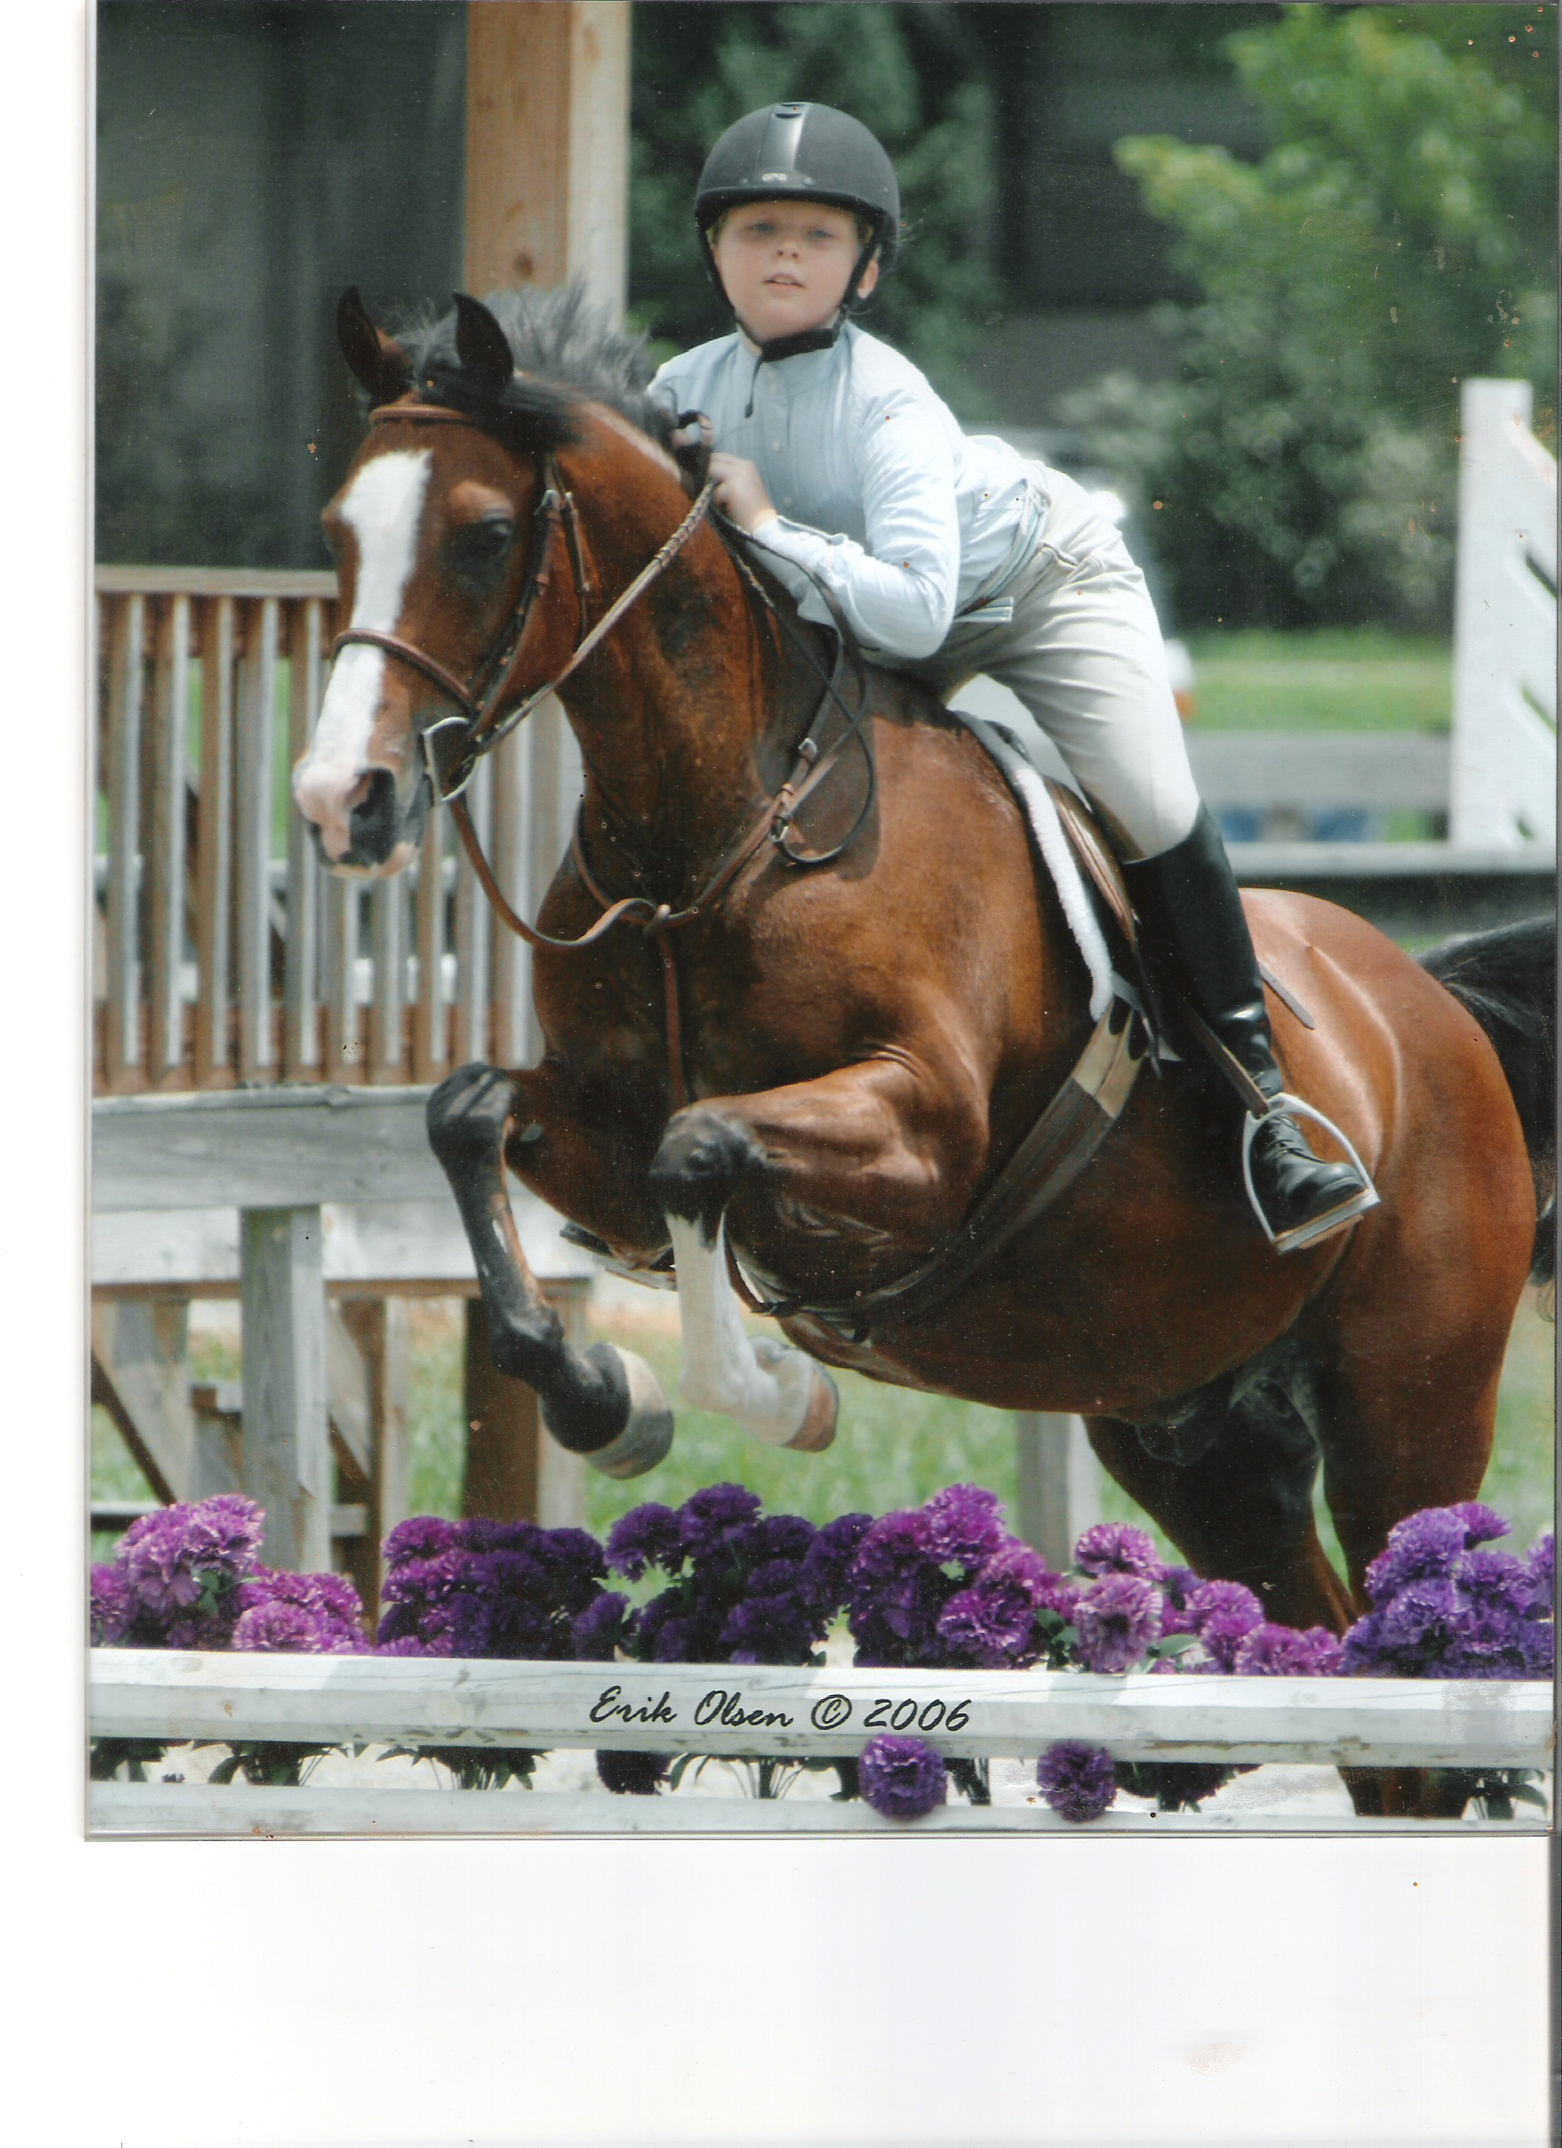

Advanced/Intermediate Camp
June 23-28
Beginner Camp
July 15-17
July 28-30

For more information call
Freda Jessen (828) 447-0652
Fern Hollow Farm is proud to offer its 11th annual Summer Riding Day Camp. This camp focuses on hunt seat riding, as well as all aspects of horse care. Campers will have daily riding lessons along with daily ground lessons about stable management and horse care in the mornings. In addition campers will hear from special guests such as a vet or farrier. They also will participate in games (both mounted and unmounted), trail rides and other fun horse related activities. We have several safe and experienced school horses that are great teachers for many levels. Campers are also welcome to bring their own horse provided it is suitable.
Beginner camp cost is $100. Adv./Intermed. Camp cost is $300.
Advanced camp includes a Carolina Schooling Series Show at Harmon field in Tryon, NC on Saturday. The extra cost includes hauling to the show, schooling at the show and the cost of one division. Any additional classes are at the expense of the camper.

$50 deposit is required to hold a spot.
Ask about family discounts.

Sample Daily Schedule

Beginner Camp
8:30 Arrive and get organized
9:00 1st group rides
2nd group stable lesson
10:00 2nd group rides
1st group stable lesson
11:00 Snack Break (campers should bring
their own snack)
11:15 Group activity/Special Guest
12:30 Camp Ends

Advanced/Intermediate Camp
8:30 Arrive and get organized
9-12 Groups rotate between riding
lesson, stable lesson and barn work
12:00 Lunch (campers should bring their
own lunch)
12:30 Afternoon activity/special guest
2:30 Camp Ends

Campers should be 6 to 15 years old.

Beginner camp is for children with little to no experience around horses, up to those who are trotting independently.
Advanced/Intermediate camp is for children who have started jumping and have done some limited cantering, up to those cantering courses and showing. This camp will attend a Harmon Field Schooling Show in Tryon, NC.
About Fern Hollow Farm
Fern Hollow Farm was established in 2001 by Freda Jessen. The farm offers hunt seat riding lessons (on school horses or private horses), boarding, training and coaching at horse shows. Fern Hollow Farm students can choose to ride for fun or compete locally and state wide. Freda’s students compete successfully at local schooling shows, and on the BRHJA and PSJ circuits
throughout North Carolina and South Carolina. They also have opportunities to hunter pace and trail ride. It is Fern Hollow Farm’s goal to produce great riders who are also knowledgeable horsemen and horsewomen.
Before founding Fern Hollow Farm, Freda Jessen was the Assistant Director of Riding at Chatham Hall (a girl’s boarding school in VA). She received her BA in Equine Business Management from St. Andrews College in 1998. While at St. Andrews Freda rode on the IHSA Team, Varsity Show Team, and at ANRC Nationals. In 2008 Freda was named BRHJA Horseperson of the Year.
For more information about Fern Hollow Farm call Freda Jessen at (828) 447-0652.

